PRODUCT REQUEST FORM
PRODUCT NAME: | Sterile Nitrile Gloves
DESCRIPTION OF REQUEST:  - New Product  - Modification  - Product Extension  - Country addition  - Label Change  - Intended Use  -…Etc… | This initiative targets the foundational and high-volume need for personal protective equipment (PPE) within the $15.6 billion U.S. compounding pharmacy market and is essential for executing our strategy as a comprehensive, compliance-focused distributor.  1. Project Background  Sterile compounding is governed by stringent USP <797> standards, which mandate the use of specific PPE to ensure product sterility and operator safety. Sterile Nitrile Gloves are a non-negotiable, consumable cornerstone of these protocols,  As highlighted in our channel plan, the market for compounding consumables is substantial ($2.34 - $3.12 billion), with glove consumption being continuous and high. However, the regulatory and validation burden of introducing a new glove brand, especially from a new manufacturing source, is significant. Therefore, the most effective and low-risk strategy is to distribute an established, trusted U.S. brand that is already recognized and accepted by pharmacy procurement and quality assurance teams. This approach:  - Provides immediate access to a high-turnover, recurring revenue stream with a product that has pre-existing market validation.  - Eliminates complex regulatory hurdles associated with new product introductions in this highly sensitive category.  - Solidifies our “one-stop-shop” value proposition by adding a critical, workflow-mandated item to our growing portfolio of compliance consumables.  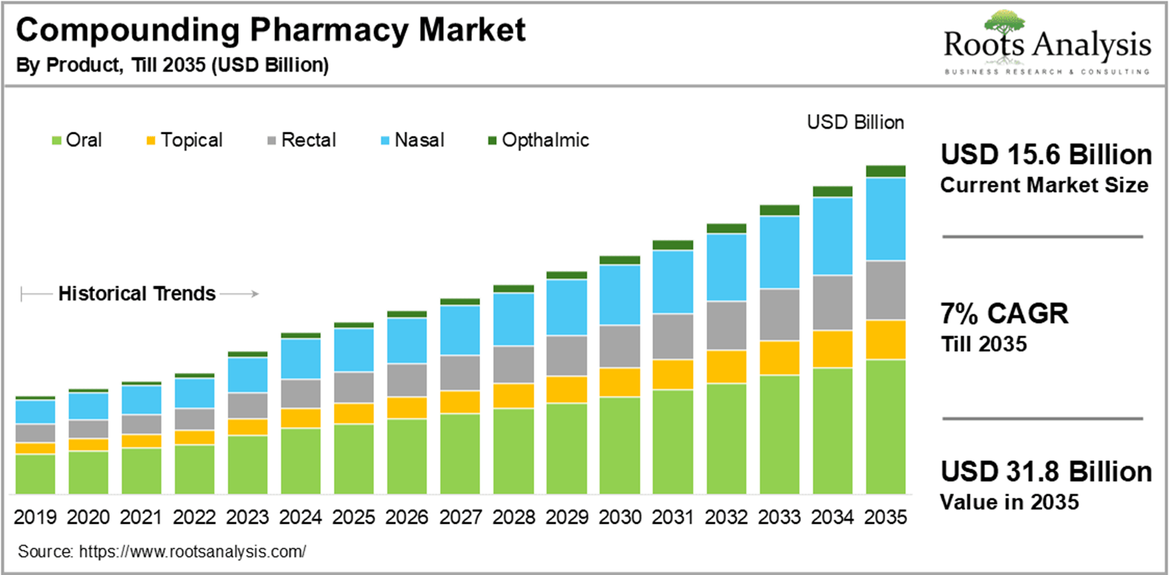
PURPOSE OF REQUEST: | ☐Complaint No. ☐Supplier ☒New market_______US_________  ☐Customer ___ ☐Internal _ ☐Other________________________  Add details:
ESTIMATED BENEFITS: | ☒ Financial Benefit:_ Complete the product lines for the Compounding Pharmacy markets, Annual sales amount $ 94M__ (Mandatory For NPD request)  Estimate the potential increase in cash flows, revenues, or any other financial benefits  ☐ Cost Saving:__________  Decrease in the cogs, transportation or operation expenses, or any other cost-saving opportunities  ☐ Improved Operational Efficiencies:_________  Decrease in the Lead time, delivery time, MOQ, Inventory, or any other efficiency improvement  ☐ Non-Financial Benefits:_________  Quality Improvement; Enhanced customer satisfaction, product competition, Brand reputation, etc.  ☐ Other Benefits:__________
PRODUCT DESCRIPTION:  - Functional performance requirements  - Appearance  - Any unique points of differentiation against similar competitor product lines  . ..Etc… | Product Definition & Scope 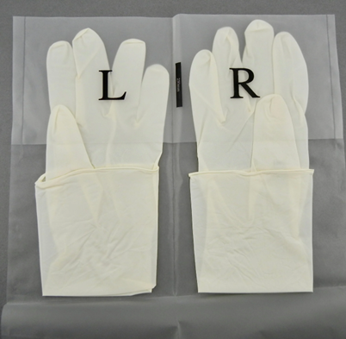  - Product: Sterile, powder-free nitrile gloves, in sizes S-XXL, meeting ASTM D3578 and D6319 standards for use in sterile compounding environments.  - Primary Use: As essential PPE for personnel performing sterile compounding activities within ISO 5 environments, directly supporting compliance with USP chapters.  - Partner Profile: A leading U.S. manufacturer or master distributor with a robust quality system, comprehensive regulatory documentation, and a strong reputation for consistency and reliability in the healthcare market.  3. Agent Brand Proposal  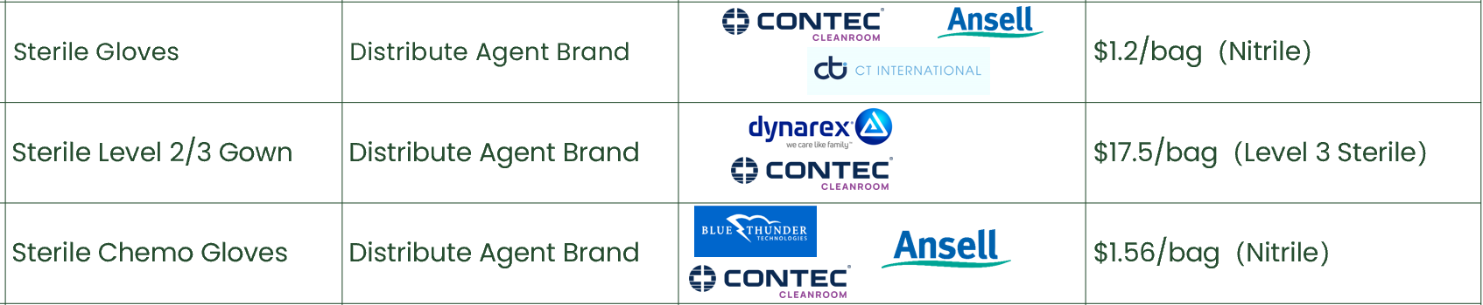
REQUEST TYPE | ☐LCR (Labelling Change Request)  Changes on the labels without changing the products  ☐SCR (Supplier Change Request)  Change applications initiated by Suppliers  ☐ECR (Engineering Change Request)  Existing products that SOLM is the legal manufacturer  Engineer changes that are not bringing new hazards/risks  ☐NPD (New Product Development)  Develop new innovative products that SOLM will be the legal manufacturer  Significant changes on existing products that may bring new hazards/risks or new intended use  Change products from outsourcing to SOLM to be the legal manufacturer  Development of VET/Component products  ☒SDP (SOLM Distributor Product)  New product introduction that SOLM will not be the legal manufacturer  No change on the product, no SOLM information on the labels  ☐SPP (SOLM Portfolio Product)  New product introduction that SOLM will not be the legal manufacturer  No change on the product, Add SOLM information on the labels  ☐Customized Product / Market  Purchased products that SOLM is not the legal manufacturer  Engineering change on products or new customized products requested by SOLM  New Market region requested by SOLM
TARGET MARKET: | ☒ US ☐ Canada ☐ EMEA ☐ UK ☐ Brazil ☐ Australia & New Zealand ☐ Other countries/regions, list:
TARGET USE: | ☒ Human Use  ☐ Animal Health | STERILE | ☒ YES  ☐ NO
VOLUME/SALES OPPORTUNITY: | Launch volume required: | Yr 1 estimate | Yr 2 estimate
CUSTOMER NOTIFICATION | Do we have any special quality agreement in place with customer which requires approval before implementing changes? ☐ YES ☒ NO  If Yes, please provide the customer's name and evidence.  Attach the customer confirmation GF-0083 at the end of the form.  Is notification to the customers needed after change project is closed? ☐ YES ☒ NO  Remark:  Example: change affect regulatory, performance, appearance, etc. Notification method.
LEGAL MANUFACTURER: | ☐ Sol-Millennium  ☒ Other: __________ | BRANDING | ☐ Sol-Millennium  ☐ Private Label
EXPECTED PRODUCT LAUNCH PERIOD: | ☒ < 1 year  ☐ 1-3 year  ☐ > 3 years | EXPECTED PRODUCT LIFE PERIOD: | 10 years
NAME AND DATE of REQUEST: | Alex Lu 2026/2/9

Product | COO | McKesson Uni Price | Target Uni Price | Target Gross Margin | Annual consumption in US | Solm采购量（10% ） | Est. Sale Revenue
Sterile Nitrile Gloves | US | 1.97 | 1.18 | 40% | 800,000,000 | 80,000,000 | 94,400,000

